Lesson 5 Demo 19: Logging Drivers

This section will guide you to:

* Configure the default logging driver
* Configure the logging driver for a container
* Configure the delivery mode of log messages

**Step 1:** Configure the default logging driver

* Use the following command to navigate to *daemon.json* and open it:

*sudo nano /etc/docker/daemon.json*



* Add the following code in the *daemon.json* file to set the *logging driver* to *syslog*:

*"log-driver": "syslog"*

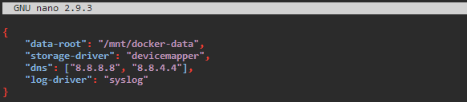

**Note**: Press **Ctrl+X** to exit the editor. Then type **Y** and press **Enter** to save the file.

* Use the following command to restart the Docker daemon:

*sudo service docker restart*

**

* Use the following command to check the current default logging driver:

*sudo docker info --format '{{.LoggingDriver}}’*



**Step 2:** Configure the logging driver for a container

* Use the following command to start a *nginx* container with the **journald**logging driver:

*sudo docker run -it --log-driver journald --name mycustom nginx*

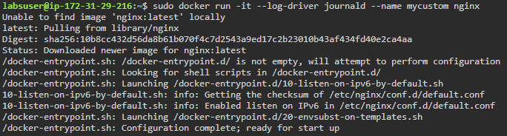

*sudo docker ps -a*

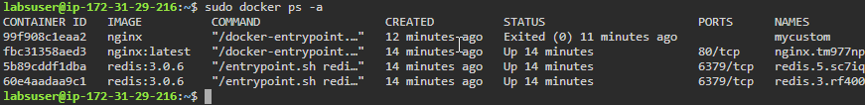

* Use the following command to check the current logging driver for a running container:

*sudo docker inspect -f *

*'{{.HostConfig.LogConfig.Type}}' mycustom*

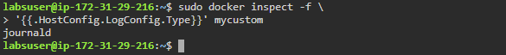

**Step 3:** Configure the delivery mode of log messages

* Use the *mode* log-option to choose from *blocking* and *non-blocking* message delivery mode
* Use the following command to start a *busybox* container with log-output in non-blocking mode and a 3-megabyte buffer:

*sudo docker run -it --log-opt mode=non-blocking *

*--log-opt max-buffer-size=3m --name busybox_container busybox*

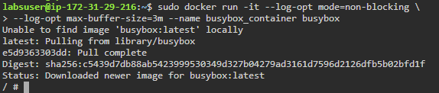

**Note**: In order to exit from this container editor type **exit**

* Use the following command to inspect a container for **LogConfig***:*

*sudo docker inspect busybox_container*

